**Coding Assignments**

1. **Hello World Program**: Write a Java program that prints "Hello World!!" to the console.
2. **Compile with Verbose Option**: Compile your Java file using the -verbose option with javac. Check the output.
3. **Inspect Bytecode**: Use the javap tool to examine the bytecode of the compiled .class file.
4. 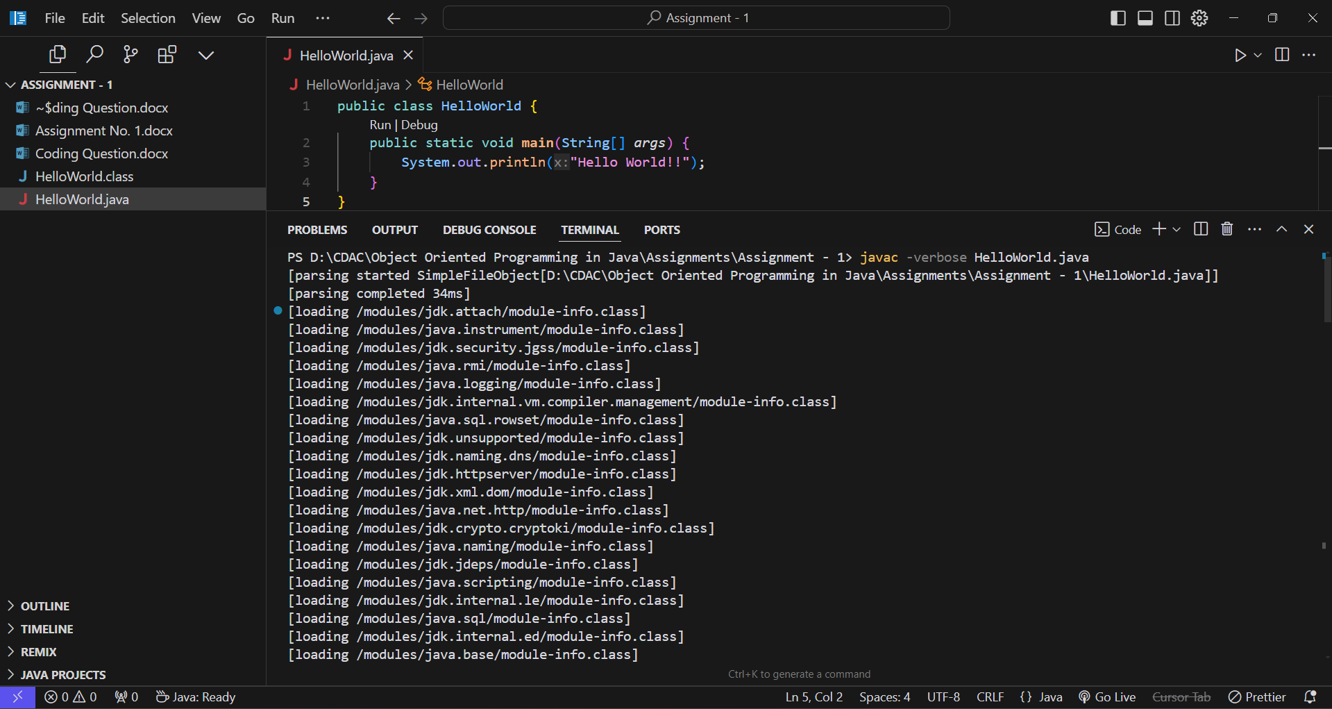Observe the output.

